Warman Design Project

Team 42

Jawal Trivedi, Benedict Loeng, Norman Cardon & Max Gu

Table of Contents

Design Summary 4

Product Design Specification 4

Functional Requirements 4

Other Requirements 4

Design Objectives 4

Product Decomposition 5

Brainstorming and Research 5

Depositing Balls 5

Securing Balls 5

Moving the System 5

Providing Power 5

Transmitting Power 5

Morphological Analysis 6

Concept Designs 1 6

Concept 1 7

Concept 2 7

Concept 3 7

Concept 4 7

Concept 5 8

Pugh’s Matrix 1 8

Concept Designs 2 9

Concept 6 9

Concept 7 9

Concept 8 10

Concept 9 10

Pugh’s Matrix 2 10

Final Design Sketch 11

Calculations 12

Mass 12

Motor 12

Battery 12

Geometry 12

RUNscore estimate 12

Cost 12

Treaded Wheels 12

Final Design 12

Depositing Container 12

Treaded Wheels 12

Scissor Mechanism 13

Operation on the Track 13

Conclusion 13

Teamwork Reflection 13

Reflection on Design Process 13

Appendices 16

Appendix A – Table of Figures 16

Appendix B – Table of Tables 16

Appendix C – Table of Equations 16

Appendix D – Table of Links 20

Design Summary

The Warman design project for 2020 requires an automated system to deposit balls into a series of tubes located around a course. The system also needs to avoid an obstacle located in the middle of the course. Furthermore, it must return to the beginning once it has deposited all the balls and this must be done in under 120 seconds.

Product Design Specification

Functional Requirements

* System must be able to carry 10 Wilson Tour Competition Tennis Balls and deposit them into 4 vessels.
* System must be autonomous, cannot have any physical contact with any team members or use any wireless systems to alter its path.
* The system must navigate around or over obstacles on the track, which include a PVC rod and the 4 vessels.
* The vessels vary in height; therefore, it must deposit certain amounts of balls into each vessel.

Other Requirements

* System cannot exceed a mass of 6kg.
* Initial total cubic volume of 500mm x 500mm x 500m.
* System must leave the start/end zone, navigate through the 2.4m x 1.2m track, complete the deposit functions and return to the start/end zone in under 120 seconds.
* The system cannot have any untethered flying systems, and at any given time a part of the system must be in contact with the track.
* Considering the spirit of the competition, the system must be built using off the shelf parts (excluding LEGO), meaning an established system cannot be bought, although parts may be modified.
* Must be started by a single action by a team member without imparting energy (such as pushing).
* System cannot leave parts behind on the track apart from the payloads.
* Each tennis ball must have a diameter of 6.75cm.

Design Objectives

* Minimise the time it takes to complete the requirements set out by the Warman Design Competition.
* Maximise the safety precautions such as by conducting risk assessments and testing, to minimise risks to spectators and potential users.
* Minimise the cost of production, to reduce the associated number of parts and difficulty of assembly.
* Minimise the steps of manufacturing so assembling the system is easier.
* Minimise the mass of the system.
* Maximise the total score of the system operating around the course.
* Maximise the accuracy of depositing payloads, to gain a higher score.

Product Decomposition

The blue boxes represent critical subproblems (Refer to Figure 1).

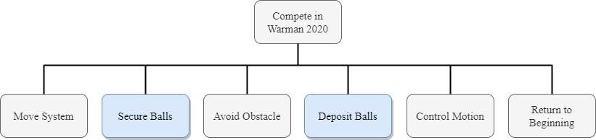Figure - Product Decomposition

Brainstorming and Research

Depositing Balls

* A crane mechanism to deposit balls individually or a robot arm to grab balls.
* A pipe/tube to lock onto the top of a vessel and deposit balls with great accuracy.
* 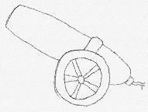Projectile via cannon or spring.
* A ramp for balls to slide down and fall in.
* A flying mechanism or drone to deposit balls.

Securing Balls

* A basket or hopper of balls.
* Vertical or horizontal tubes each containing the amount of balls needed to deposit in each vessel, also has an openable lid.
* 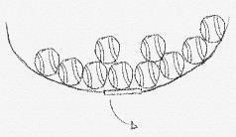Dispenser of some kind.
* Tubes turning to store balls, could also be adjusted into a depositing mechanism.

Moving the System

* Wheels, front vs back wheel drive. Also, have different kinds of wheels:
  + 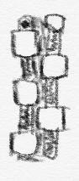mecanum wheels, omni wheels or tires.
* Tracks like on a tank.
* Scissor Mechanisms and Hydraulics to adjust height
* If system stationary, then for support:
  + pillars, hydraulics, pillars, blocks, metal stands.

Providing Power

* A drawing on a necklace

  Description automatically generatedElectric motors
* Engines, diesel or petrol
* Gears or purely mechanical system
* Solar power
* Wind

Transmitting Power

* Hydraulics
* Chains or gears
* A chain in a body of water

  Description automatically generatedBelts
* Electrical via wires from battery

Morphological Analysis

|  |  |  |  |  |  |  |
| --- | --- | --- | --- | --- | --- | --- |
| Sub-Problems | Sub-Problem Alternatives | | | | | |
| Depositing | Robotic Arm | Crane | Cylindrical Containers | Box Container | Spiral Tube | Projectile Cannon |
| Storage | Hopper | Cylindrical Container | Dispenser | Spiral Tube |  |  |
| Providing Support | Wheels | Tracks | Skis | Balloon Tyres | Mecanum Wheels | Omni-directional wheels |
| Power | Electric motor | Petrol Engine | Diesel Engine | A picture containing game, table  Description automatically generatedSolar Power | A drawing on a necklace  Description automatically generatedWind Power |  |
| Transmitting Power | Gears | Hydraulics | A chain in a body of water  Description automatically generatedBelt Drive | A screenshot of a cell phone  Description automatically generatedPneumatic | Chain drive   |  |

Table - Morphological Analysis

Concept Designs 1

From the Morphological Analysis (Table 1 - Morphological Analysis), each member came up with concept designs which was presented to the rest of the group.

Concept 1

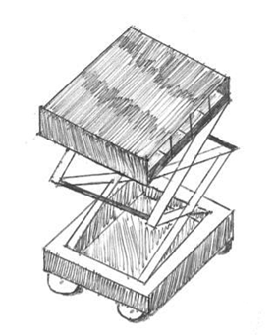Scissor mechanism lifts the top plate up and down so that one of the four gates on the left side of the sketch aligns with the top of the vessel.

Behind each gate is the amount of balls required to go into each vessel on a ramp. Therefore, when the gate is removed the balls will roll down and drop into the vessel.

Figure - Concept Design 1

Concept 2

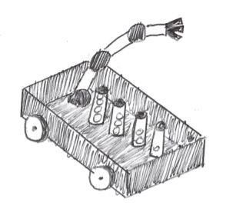The robot arm grabs a cylinder corresponding to a specific vessel. It then tilts the cylinder or rotates it upside down to deposit the balls into the vessel.

The containers are designed so when turned upside down or tilted they will fall open and let the balls out.

Figure - Concept Design 2

Concept 3

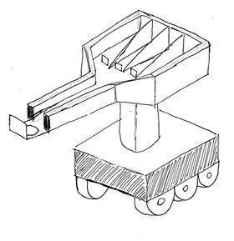The robot arm is designed to quickly deposit payloads into vessels. It does this by shooting the balls along the arm track and down the hole via a spring.

The container is divided into four spaces to separately store the payloads. The small gate inside the container will fold down when the robot reaches its target.

Figure – Concept Design 3

Concept 4

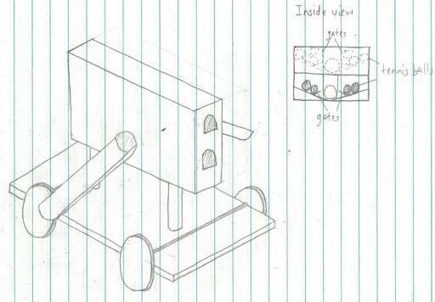This design uses 2 pipes to deposit balls on either side of the device, and balls are fed into these pipes via a large central storage unit. The storage container is split into 4 compartments where balls are stored: 2 in the top section, and 2 in the bottom section. In each compartment, balls are held by electronic gates which can release balls into one of the two pipes, and the right one is placed higher since the ball receptacles are higher on the right side. The inspiration for this design is the previous pipe-based design. This design is an improvement of the original design, improving aspects such as accuracy with the fixed height pipes, and improving the ease of assembly by reducing the number of moving parts.

Figure - Concept Design 4

Concept 5

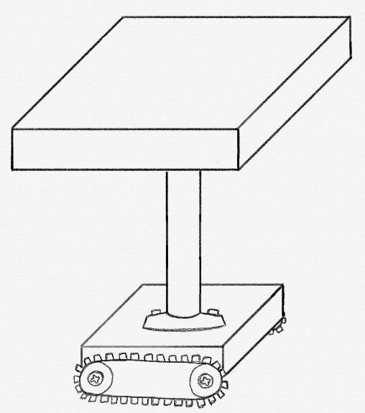The robot has a depositing container on top which drops the payloads into the drop-zones once the robot has aligned itself. The primary way of manoeuvring the robot is via tracks. This design seemed optimal to get over the angled obstacle.

The inspiration for the depositing container came from the game 100 Balls refer to Appendix D – Link 3 (Page 20) The chassis and the tracks idea came from military tanks and how easy it is for them to getover obstacles (as shown in movies) .

Figure - Concept Design 5

Pugh’s Matrix 1

|  |  |  |  |  |  |
| --- | --- | --- | --- | --- | --- |
| Categories | Concept 1 (Baseline) | Concept 2 | Concept 3 | Concept 4 | Concept 5 |
| Stability | Not great because it only has 1 pillar to stand on. Could add more.  N/A | Scissor mechanism, not very stable. Could make it a double scissor mechanism.  -VE | The arm of the robot could change the Centre of Mass, otherwise quite stable.  +VE | Centre of Mass would change due to extending arm. Only 1 pillar joining chassis and mechanism, thus unstable.  -VE | Quite stable due to the  position of  the wheels.  +VE |
| Accuracy | Fixed height, therefore, not great because payloads could bounce out of the drop-zones.  N/A | Quite accurate due to a varying height.  +VE | Very accurate, considering the code for the arm is done correctly.  +VE | Accurate due to the extending arm.  +VE | If the wheels align themselves properly, it could be accurate.  EQUAL |
| Speed | Tracks would be slower, and they will take time in aligning with the drop-zones.  N/A | Scissor mechanism could take time winding and unwinding, and gates could take time opening.  EQUAL | Relatively quick, deposits fast, however it will take time to put the tubes  back.  -VE | 5 motors so would be quick.  +VE | Would need to slow down when going over the obstacle.  EQUAL |
| Buildability | Depositing Container hard to build.  N/A | Depositing container hard to build, as well as scissor mechanism.  -VE | Difficult to code the robotic arm and make it precise.  -VE | Lots of mechanical parts, so had to build.  -VE | Design could be heavy, so materials cost and difficult to get the top part right.  +VE |
| Cost | Expensive due to multiple complex parts.  N/A | Quite costly due to the depositing container, as well as the scissor mechanism.  +VE | Could be very expensive due to the robotic arm.  -VE | Expensive due to the depositing container and multiple motors.  -VE | Fairly reasonable  as there isn’t  many complex mechanisms.  +VE |
| Overall | N/A | 0 | -1 | -1 | 3 |

Table - Pugh's Matrix 1

Concept Designs 2

After working on our first Pugh’s Matrix as a group, each member went home and worked on our first concept designs to improve what had been discussed. Each member came up with updated designs which are shown below. Concept Design 2 didn’t get an upgrade, as it didn’t pass out first Pugh’s Matrix.

Concept 6

Concept design 1 has improved by removing the roof of the top plate and therefore reducing mass. The balls at the top have been formatted so that the loads are more evenly spread. However, in principle, the operation of the improved design works the same as the previous. By adjusting the height of the scissor mechanism and opening gates for each vessel.A close up of a handcart

Figure - Concept Design 6

Concept 7

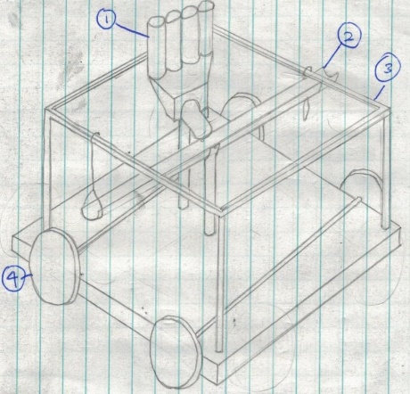This design uses a swinging pipe to distribute balls on either side of the device. It contains balls in 4 vertical tubes, which have electronic gates on them to release balls when required. The containers can rotate and deposit balls into either side of the pipe, utilising gravity to tip the pipe so balls can roll down. The pipe is attached to the thin metal frame by string at each end, which prevents the pipe from tipping too far. The inspiration in this design is the idea that gravity is the fastest way to deposit balls, and that the device would not have to turn around if the device could deposit balls on either side, saving time.

Figure - Concept Design 7

Concept 8

The previous design (Refer to Figure 4 – Concept Design 3) there was a risk of the payloads bouncing out of the drop-zones. The flexible robotic arm in this design reduces that risk. Since the robotic arm can rotate in all directions, the body of the device doesn’t need to move too much. The robotic arm uses a Pneumatic system to rotate in numerous directions.

Figure - Concept Design 8

Concept 9

This design is an improvement on Concept 5 (refer to Figure 6 - Concept Design 5). This design has a square container in which the robot stores the payloads, and when required deposits them accordingly. This design resolves the previous risk of payloads bouncing out, by making the depositing container vertically adjustable. The wheels also got an upgrade from tracks. The new wheels are wide and have custom tread which is used to go ‘through’ the obstacle placed in the middle of the course.

Figure - Concept Design 9

The inspiration for the wheels came from University of Adelaide’s Warman Design Project 2016 refer to Appendix D Link – 4 (Page 20) at a timestamp of 9:00.

Pugh’s Matrix 2

We decided it would be easier if we iterated back a step and drew up improved concept designs based on the feedback, we received in the first Pugh’s Matrix. Afterwards we performed another Pugh’s matrix to help us come up with an optimal final design.

|  |  |  |  |  |
| --- | --- | --- | --- | --- |
| Categories | Concept 6 (Baseline) | Concept 7 | Concept 8 | Concept 9 |
| Stability | Fairly Stable, due to double scissor mechanism. Potentially unstable whilst depositing. Could enlarge wheels.  N/A | Fairly stable, could enlarge wheels for more stability.  -VE | The mass of the robotic arm while depositing could alter the Centre of Mass of the system, otherwise stable.  -VE | Very Stable due to wide wheels.  +VE |
| Accuracy | Fairly accurate, if it aligns itself with the drop-zones.  N/A | Could be inaccurate for drop-zones ‘A’ and ‘B’, due to the inability to change height.  -VE | As long as the code for the robotic arm is done correct, it will be accurate.  +VE | Fairly accurate, due to varying height.    +VE |
| Speed | Scissor mechanism could take time to wind and unwind, otherwise quick. N/A | Quite fast due to low mass and multiple motors.  +VE | Robotic arm may take time aligning itself with the  drop-zones, otherwise fast.  -VE | Rollers with aligned tread means it doesn’t have to jump over the obstacle.  +VE |
| Buildability | Easy to build apart from the scissor mechanism.  N/A | Not many complex systems so should be  easily buildable.  +VE | The robotic arm would be hard to code  -VE | Difficult to build due to multiple complex systems i.e Rollers with aligned tread, scissor mechanism and depositing box.  -VE |
| Cost | Scissor mechanism, motors and microcontroller may increase the price but within reasonable range. N/A | The middle segment could be costly to build, maybe 3D print.  EQUAL | Costly due to the Robotic arm and the large support wheels. -VE | Lots of complex mechanisms means a high cost.  -VE |
| Overall | N/A | 0 | -3 | 1 |

Table - Pugh's Matrix 2

Final Design Sketch

Our Final Design comprised of components from different concept designs. The depositing container was from Concept 6 (refer to Figure 7). The Scissor mechanism was common in multiple designs, so it was an essential part of the final design. The Chassis and the wheels were from Concept 9 (refer to Figure 10). The Treaded wheels weren’t in the Morphological Analysis as they were a spur of the moment idea.

Figure - Final Design Sketch

Calculations

Mass

The calculations verifying the mass are given in Appendix C – I (Page 16). This shows that the mass is under the given constraint of 6Kg.

Motor

The motors were selected using the calculations explained in Appendix C – II (Page 16). This verifies that the best motor to use is a standard 11000 RPM DC motor from Jaycar Electronic Appendix D – 1 (Page 20).

Battery

From the calculations given in Appendix C – III (Page 17), we verified that we will require a 12V Alkaline battery. We can obtain this from Mitre 10 refer to Appendix D – 2 (Page 20).

Geometry

We have verified calculations for 3 main scenarios. The first scenario is when the scissor lift is extended to its maximum height refer to Appendix C – IV (a) (Page 17). Scenario two is when the Robot is carrying the maximum load refer to Appendix C – IV (b) (Page 18). Scenario three is when the Robot is moving with the scissor mechanism at its maximum height refer to Appendix C – IV(c) (Page 19). This section verifies that the Robot indeed won’t tip over at any crucial stage.

RUNscore estimate

We estimate that our final score at the competition will be 146. The calculations are shown in Appendix C – V (Page 19).

Cost

Our final cost of the project will result to $55.66 NZD. This cost excludes 3D printing, micro controller and other resources provided by the University. The calculations are show in Appendix C – VI (Page 20).

Treaded Wheels

The calculation for verifying whether the design of the wheel will work is given in Appendix C – VII, (Page 20) The calculation verifies that the radius of the wheel required to use the concept is 42.2mm.

Final Design

Depositing Container

The final design we came up with is an improved version of the scissor mechanism concept design. The way in which it deposits balls is by a top plate which has four sections containing the amount of balls needed for each vessel. The balls are arranged so that the centre of mass is spread as evenly as possible, Refer to Appendix A (Figure 12 - Arrangement of Payloads). When a ball reaches a vessel, it aligns itself and releases the gate corresponding to that vessel, for example at vessel A, gate A would open with 1 ball. The ball then slides down an angled railing to then fall and be deposited. This process is repeated for the other three vessels. Our design also consists of a scissor mechanism which adjusts the height of this top plate. This ensures accuracy by avoiding the balls being able to bounce out. Furthermore, the gate mechanism opens by a microcontroller.

Treaded Wheels

The method in which our design avoids the obstacle is by a deep groove bigger than the cross section of the obstacle. Therefore, if positioned correctly all 4 wheels should be able to go over the obstacle without displacing the whole robot upwards. We know this will work according to the calculations done in Appendix C - VII (Page 20) and also because it’s been done before in the 2016 Warman Design Competition by the University of Adelaide. Refer to Appendix D – 4 (Page 21).

Scissor Mechanism

The black triangular shaped connections are in fixed positions and are connected to the top and bottom plates. The grey pistons in the middle, connecting the rods, can expand and contract, which makes the scissor lift move up and down. The slots in the black metal bars have been left open for the bars to move freely. There is a motor in the scissor mechanism which makes the pistons via hydraulics longer and shorter. Therefore, we use this mechanism while the design is moving between vessels to raise the top plate to the desired height.

Operation on the Track

During the setup phase of the competition our robot will need to be aligned correctly in order to go through the obstacle. This will be accomplished by placing the robot on the obstacle and running a start-up script, which ends in the start/end zone of the track. The scissor mechanism will also be lowered to align with drop-zone **A** (lowest position).

When the time starts, our robot will travel to drop-zone **A,** through the obstacle, at a speed of 0.24 m/s. The reason we aim for drop-zone **A** first is because there is a higher risk of the payloads tipping out if the scissor mechanism is at a maximum height with all the payloads. We estimate that it will then spend approximately 5 seconds depositing the 1 payload.

The robot will then make a right turn, and simultaneously extend the scissor mechanism. This will align the robot with drop-zone **B**, it will take approximately 8 seconds to deposit the 2 payloads in the drop-zone.

In order to drop the payloads at drop-zone **C** the robot will make another right turn, and simultaneously extend the scissor mechanism. The robot will spend 10 seconds depositing the 3 payloads.

The robot will then need to travel towards drop-zone **D**. In order to do this, it will make a left turn until it aligns itself with the obstacle, and then travel straight as well as extend the scissor mechanism until it aligns itself with drop-zone **D**. It will spend an estimated 15 seconds to deposit the 4 payloads. The robot will then steer right and make its way back to the star/end zone.

Conclusion

We are confident our design will work due to previous Warman Projects using similar mechanisms and our calculations. We know from the calculation in Appendix C – IV (a) (Page 18) that the design will be stable at its maximum height and from Appendix C – IV (b) (Page 18) it will be stable when it has the maximum number of payloads. Furthermore, according to Appendix C – IV (c) (Page 19), the design will not tip over since the tipping acceleration will never be reached.

We estimate that our design will take off, dodge the obstacle, drop the payloads into the vessels and return to its original position, and save the planet of Gondwana in approximately 68 seconds. Therefore, our final calculated score is 146 for the Warman Project 2020 FLAMEOUT. Refer to Appendix C – V (Page 20).

Teamwork Reflection

Reflection on Design Process

Our group followed the Design Process that was taught in MECHENG 235 reasonably well. However, there were moments which weren’t part of the Design Process.

There were a few methods which worked generally well for us. For example, during the first few days when we were just getting familiar with the project as well as each other, we communicated our ideas quite well. This allowed us to adapt with each other quickly. The Design Process suggested an elaborate and non-critical brainstorm, which went well. It also recommended a Morphological Analysis to focus on sub-problems in order to come up with Concept Designs. This phase was completed during tutorials (pre-lockdown) in a highly supportive environment. Everyone participated evenly during this phase, which is why we were able to come up with multiple Concept Designs. Following the Design Process, we went on to complete our first Pugh’s Matrix as a team. This exposed us to our team members’ ideas which we could implement into our own Concept Design. For this reason, we iterated a step back and came up with another set of Concept Designs. This allowed each team member to submit an optimal Concept Design for our second Pugh’s Matrix. From there, all that was left was to choose the best one. However, we applied our knowledge from the course and decided to mix and match to create the best possible design of a device.

We learnt from the design process how to effectively come up with a concept design to solve a non-routine design problem and how to show if the concept would work. This was accomplished by formatting a PDS based off the project rules and then coming up with a range of ideas based of these requirements. We further evaluated a range of concept designs and eventually came up with a final design. Furthermore, we learnt how to verify the final concept design by checking its geometry and how to effectively select motors and batteries. Overall, the team as a whole learnt a lot about the mechanical design process.

There were moments where our team didn’t strictly follow the design process. An example is when we had new ideas to add, we didn’t evaluate them using a Morphological Analysis, we directly added it into our Final Design. As a group we aim to change this in our next design project, and use the proper procedure taught to us. Another aspect on which we could improve is our planning. We didn’t spend too much time planning the project, which resulted in disorganisation. Furthermore, we also didn’t spend much time researching a range of main concepts. For example, some of our initial concept designs were similar. In the next design process, we will aim to spend more time planning the weeks to come and try to rigorously follow it. We didn’t spend too much time on sketching up the Final Design. This cost us as a lot of design issues could’ve come up if a Final Design sketch was iterated a few times. Furthermore, we also left the calculations a bit to late and relied on CAD for dimensions rather than estimating them ourselves. Also, due to lack of communication about the final design, calculations took a lot longer than they should have which led to time pressure before the deadline.

Splitting tasks among team members worked well. We found the team was more productive in some respects than others when they got to work individually on a task. However, we also found some tasks were better off done as a team, like the PDS or Pugh’s Matrix. The CAD worked well for us; however, the time management could have been done better. For example, one team member did most of the CAD, however, dividing the CAD workload would’ve been much more effective.

Overall the team was quite happy with the way the Design Process was implemented. There were instances which we regret, however we understand that this is a learning curve and aim to improve upon them in the next project.

Appendices

Appendix A – Table of Figures

Figure 1 - Product Decomposition 5

[Figure 2 - Concept Design 1 7](https://uoa-my.sharepoint.com/personal/jtri402_uoa_auckland_ac_nz/Documents/Warman%20Design%20Project%20(4).docx#_Toc37339250)

[Figure 3 - Concept Design 2 7](https://uoa-my.sharepoint.com/personal/jtri402_uoa_auckland_ac_nz/Documents/Warman%20Design%20Project%20(4).docx#_Toc37339251)

[Figure 4 – Concept Design 3 7](https://uoa-my.sharepoint.com/personal/jtri402_uoa_auckland_ac_nz/Documents/Warman%20Design%20Project%20(4).docx#_Toc37339252)

[Figure 5 - Concept Design 4 7](https://uoa-my.sharepoint.com/personal/jtri402_uoa_auckland_ac_nz/Documents/Warman%20Design%20Project%20(4).docx#_Toc37339253)

Figure 6 - Concept Design 5 8

[Figure 7 - Concept Design 6 9](https://uoa-my.sharepoint.com/personal/jtri402_uoa_auckland_ac_nz/Documents/Warman%20Design%20Project%20(4).docx#_Toc37339255)

[Figure 8 - Concept Design 7 9](https://uoa-my.sharepoint.com/personal/jtri402_uoa_auckland_ac_nz/Documents/Warman%20Design%20Project%20(4).docx#_Toc37339256)

Figure 9 - Concept Design 8 10

[Figure 10 - Concept Design 9 10](https://uoa-my.sharepoint.com/personal/jtri402_uoa_auckland_ac_nz/Documents/Warman%20Design%20Project%20(4).docx#_Toc37339258)

[Figure 11 - Final Design Sketch 11](https://uoa-my.sharepoint.com/personal/jtri402_uoa_auckland_ac_nz/Documents/Warman%20Design%20Project%20(4).docx#_Toc37339259)

Figure 12 - Arrangement of Payloads 16

Figure - Arrangement of Payloads

Appendix B – Table of Tables

Table 1 - Morphological Analysis 6

Table 2 - Pugh's Matrix 1 9

Table 3 - Pugh's Matrix 2 11

Appendix C – Table of Equations

1. Mass Calculations

One of the fundamental requirements of project FLAMEOUT is to minimise the mass (maximum 6kgs), therefore the total mass of our robot is given by;

Our estimate of the small DC motor is ~ 150 grams, and the battery is ~ 30 grams. The mass of the Depositing Container, the Chassis and the Scissor mechanism is given by our CAD model.

This calculation shows that our design is less than 6 Kgs, so it fits the given constraints.

1. Motor Calculations

The following calculations allowed us to find a motor which could power and satisfy our design. First we estimated the distance and time spent travelling the course (nonstop). Since the total length of the route seemed very close to twice the whole length of the track, we decided the distance travelled would be approximately:

We also estimated that the time to travel this distance and avoid losing payloads or undergoing slip would be 20s. Therefore, the average velocity is:

The mass of the robot without any load is 5kgs, therefore, if we simplify the model and assume a weight of 49.05N (5 X 9.81) is symmetrical, then the normal force is equal to the weight 49.05N but in the opposite direction. The wheels are made from rubber so the Static Coefficient of Friction between the rubber wheels and wooden ground is 0.95. Therefore, friction can be calculated as:

Since we know the speed and force we can calculate an estimated power to get the robot moving:

We then estimated the transmission efficiency as 0.7, 1 meshed pair, in order to calculate the power at the motor:

The capacity of the motor needs to be much greater than this power in order to compensate for extra friction in other places and changes in gradient of the surfaces, therefore:

The motor we have selected is a high power DC motor (refer to Link - X). According to the motor’s datasheet (given on the webpage), the rpm value at 31.95W is 10100RPM. We can convert this to more conventional units:

From this, we can calculate the velocity the motor will produce and compare this to the desired velocity:

For the velocity to be at 0.24m/s, we need an 8:1 reduction ratio. The transmission efficiency was also assumed correct as one meshed gear is needed. Therefore, the motor selected should be more than satisfactory for the task required in project FLAMEOUT.

1. Battery Calculations

The following calculations determine the battery requirements and verify a capable battery.

We estimated that the robot will take 5 seconds at A, 8 seconds at B, 10 seconds at C and 15 seconds at D to deposit the payloads. Plus 30 seconds travelling time. Thus, the estimated complete time is about 70 seconds.

As the motor is operating at a power of 31.95 w, we can conclude that the energy consumed by the motor is:

Energy should be enough to complete two runs of the course, therefore:

We can calculate the total charge required for a 12V battery as:

As a result, the capacity of the batteries needs to be:

Therefore a Energizer Alkaline battery will be sufficient (refer to Link X+1).

1. Geometry Calculations
   1. Case 1: Robot extended to maximum height

At maximum height the ball carries 4 payloads in slot D of the top section, therefore, the mass due to the balls is:

From CAD model (centre of slot D to outer edge) we know that:

We calculate the sum of the moments around wheel 1 (point 1) to determine N2:

Then use the sum of the forces in the y direction to calculate N1:

We then sum the moments about this origin point to determine whether the device is stable:

The moment calculated is very small, therefore, the device at maximum height will not fall over.

* 1. Case 2: Robot carrying maximum load

At max payload, the robot is carrying 10 payloads, therefore:

Form the CAD model:

We take the sum of the moments at wheel 1 in order to find N2:

By taking the sum of the forces in the y direction we can calculate N1:

By taking the sum of the moments at the origin we can verify if the device will tip over or not at point O:

The moment is very small; therefore, the device will not tip over when loaded with all 10 payloads.

* 1. Case 3: Robot moving at maximum height

Assumption: Friction only occurs between the wheels and ground.

At this scenario, N2 = 0 (wheel 2 has started to lift off the ground). This will allow us to determine what the acceleration is at this point and whether our robot will reach this max acceleration.

By taking the sum of the moments at point O, we can determine the friction at wheel 1:

Therefore, the max acceleration at max height to cause the device to lift and fall over would be:

This max acceleration is much greater than any speed we will be putting our robot at, therefore, it’s safe to assume that it is very unlikely our robot will lift and fall over while travelling.

1. RUNscore estimate

The equation to calculate the RUNscore is given by:

In calculating the RUNscore, we are going to assume that all of the payloads have been correctly deposited, and that the robot has returned to the staring position.

We also estimate that it will take 5 seconds to deposit at drop-zone **A**, 8 seconds at **B**, 10 seconds at **C** and 15 seconds at **D**. So our total time is 68 seconds

So then:

1. Cost

The cost of the robot includes motor, battery and a gearbox. The rest is neglected as it can be provided by the university.

1. The motor we have decided on is a standard, high power DC motor from Jaycar Electronics. We will require 3 motors, therefore the total cost for motors will equate to $47.70 NZD.
2. The battery requirements suggest that we will need two 12V batteries required to complete the run. At a cost of $3.98 each from Mitre 10, the total cost of batteries will equate to $7.96 NZD.

The total cost will equate to:

1. Treaded Wheels Calculations

The obstacle goes through the wheel at an angle of 45 degrees, therefore we can calculate the minimum radius needed to go over the obstacle:

From the diagram we know theta equals 36.015 degrees, thus we can determine the radius:

The minimum radius needed to pass the obstacle is 42.2mm, therefore, since our wheels have a radius of ~49mm, our design should be more than capable of going through the obstacle

Appendix D – Table of Links

1. <https://www.jaycar.co.nz/standard-high-power-d-c-motors-11000-rpm/p/YM2770>
2. <https://www.mitre10.co.nz/shop/energizer-alkaline-battery-a23/p/108112?gclid=CjwKCAjwpqv0BRABEiwA-TySwbh49wF-codPZrDC6ocov0Qf4W5WjV8AzJyKZk7cu4famZ0zBl7WQRoCJVYQAvD_BwE&gclsrc=aw.ds>
3. <https://lagged.com/play/1210/>
4. <https://www.youtube.com/watch?v=cvdrXF4FR5E&t=550s>

**MECHENG 235: Teamwork Reflection Exercise**

Write a sentence under each point. “Nothing” is not an acceptable response. This reflection is not confidential - it will be shared and discussed among all the project team members at a tutorial. All comments should be constructive and respectful.

***My name: Jawal Trivedi***

**Self-reflection on my contributions as a team member on this project (to complete before the discussion session)**

Describe a situation where I could have been more effective as a team member:

I could have done a few calculations and helped on the CAD models.

Describe what I learned from this situation, i.e. what I plan to do differently next time

Rather than procrastinating on it, I should’ve started on the report early on. So there would be clearance for proof reading etc.

Describe a time when I showed empathy towards another team member’s teamwork situation:

When Max was overworking himself with the CAD modelling, I asked him to take a break as I was worried about his health and wellbeing.

**Feedback for my team members (complete before the discussion session)**

***Team member 1 name: Norman Cardon***

Describe an aspect of the team member’s teamwork that you appreciated during the project:

You had some great ideas for concepts and worked smarter rather than harder, which was very useful.

Any other feedback to offer?

You had great drawing skills which helped communicate your concepts efficiently.

***Team member 2 name: Benedict Loeng***

Describe an aspect of the team member’s teamwork that you appreciated during the project:

He was very diligent and delivered everything that was asked of him.

Any other feedback to offer?

Voice your opinion a bit more, you have some brilliant ideas.

***Team member 3 name: Max Gu***

Describe an aspect of the team member’s teamwork that you appreciated during the project:

Very hard-working person. He perfected everything he did and delivered everything that was required of him.

Any other feedback to offer?

Keep everyone updated a bit more often, so we can do our work accordingly.

**Complete this part during or after the discussion:**

Two points I aim to work on, or things I aim to do differently, to develop my own teamwork skills during the next design project:

1. Communicate with my team members more often and take more responsibility and initiative for the work.
2. Next time I would aim to organise more meetings outside of the two delegated tutorials per week. This is to get regular updates on each other’s work.

**MECHENG 235: Teamwork Reflection Exercise**

Write a sentence under each point. “Nothing” is not an acceptable response. This reflection is not confidential - it will be shared and discussed among all the project team members at a tutorial. All comments should be constructive and respectful.

***My name: Norman Cardon***

**Self-reflection on my contributions as a team member on this project (to complete before the discussion session)**

Describe a situation where I could have been more effective as a team member:

I could have been a more effective team member during the calculations phase. I left these too late and relied heavily on the CAD for dimensions rather than doing them early and estimating dimensions.

Describe what I learned from this situation, i.e. what I plan to do differently next time:

I learnt that I should try to communicate with my team more effectively and ask for their inputs on what the overall dimensions should be and how I should go about calculating them.

Describe a time when I showed empathy towards another team member’s teamwork situation:

A team member was quite inactive for a weekend due to real life situations; therefore, I was understanding when he couldn’t do any work.

**Feedback for my team members (complete before the discussion session)**

***Team member 1 name: Max Gu***

Describe an aspect of the team member’s teamwork that you appreciated during the project:

Amazing at CAD, really worked hard in this department and produced some amazing products.

Any other feedback to offer?

However, didn’t communicate too us well about the CAD model or explain how certain parts were going to operate.

***Team member 2 name: Jawal Trivedi***

Describe an aspect of the team member’s teamwork that you appreciated during the project:

Did a really good job with the report and its formatting. I initially started off the report, however, he managed to make it look a lot better.

Any other feedback to offer?

Try and follow the rubric more to avoid unnecessary information.

***Team member 3 name: Benedict Loeng***

Describe an aspect of the team member’s teamwork that you appreciated during the project:

Helped me with some of the calculations and provided useful feedback at times when I provided him questions or workings about the calculations

Any other feedback to offer?

Spend more time on your calculations, sometimes they seemed rushed.

**Complete this part during or after the discussion:**

Two points I aim to work on, or things I aim to do differently, to develop my own teamwork skills during the next design project:

1. Communicate more effectively about what I’m doing for the project with my team.
2. Do more research towards the design problem and come up with a wider variety of solutions.